WESTERN PACIFIC UNIVERSITY
CMN224 / CMP224 Software Engineering — Week 9
Lab 6: Behavioural Diagrams for Your Client
Formative (ungraded) · Moodle-enabled · completes the modelling half of Task 4 (15%, due Week 11)
Item | Details
Linked to | Week 9 lecture — Behavioural UML and the 4+1 view model (ULO2, ULO4)
Work mode | Individually, on the SAME client you used for Task 2 and Lab 4
Time | About 90 minutes
Tools | diagrams.net desktop OR PlantUML — free, offline, both cached on Moodle
Submission | Four diagrams + this worksheet to Moodle AND committed to week09/ in your portfolio
This finishes Task 4. Task 4 (Design & Modelling Deliverable, due Week 11) asks for a use-case model, a class diagram, state and activity diagrams, an outline architecture and one applied design pattern. Lab 4 gave you the architecture. Today gives you the four diagrams. Week 13–14 supplies the pattern.
Part A — Use case diagram (20 min)
Show the actors, the system boundary and 5–9 use cases. Each use case is a goal in the actor's language, not a screen or a button.
Case B — Waghi Valley Produce Cooperative, near Mt. Hagen
A 300-member cooperative buying coffee and vegetables from members at a roadside depot, then selling in bulk. Intake is recorded in carbon-copy books; members are paid fortnightly. The depot has no mains power (solar + generator), no fixed internet, and patchy mobile signal. The manager wants to stop losing member records and payment disputes.

# | Check before you move on | Done
1 | Every actor is a ROLE, not a named person | Actors:  - Bulk buyer  - Desktop clerk  - Treasurer  - Cooperative manager
2 | Every use case is a goal (a verb phrase the client would recognize) | Use case:  - Register Member  - Record Produce Intake  - Verify Member Record  - Calculate Member Payment  - Process Fortnightly Payment  - Check Payment History  - Generate Produce Report  - Record Bulk Sale  - View Member Balance
3 | The system boundary is drawn — it is clear what is outside | System boundary:  Waghi Valley Produce Cooperative, near MT.Hagen
4 | Every use case traces to a user requirement in your SRS | Where it comes from:  The use cases come from the case requirements about recording member produce, maintaining member records, making fortnightly payments, reducing payment disputes, and recording bulk sales.
PlantUML starter
@startuml
left to right direction

actor "Depot Clerk" as Clerk
actor "Cooperative Manager" as Manager
actor Treasurer
actor "Cooperative Member" as Member
actor "Bulk Buyer" as Buyer

rectangle "Waghi Valley Produce Cooperative Management System" {

Clerk --> (Register Member)
Clerk --> (Record Produce Intake)
Clerk --> (Verify Member Record)

Manager --> (Generate Produce Report)
Manager --> (View Member Balance)

Treasurer --> (Calculate Member Payment)
Treasurer --> (Process Fortnightly Payment)
Treasurer --> (Check Payment History)

Member --> (Check Payment History)
Member --> (View Member Balance)

Buyer --> (Record Bulk Sale)
Manager --> (Record Bulk Sale)
}

@enduml

PlantUML Diagram
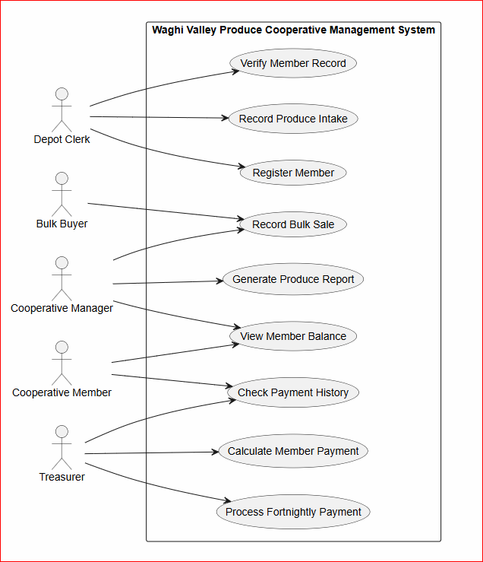

Part B — Class diagram (25 min)
Show 4–7 classes with attributes, key operations, named associations and multiplicity. Read your SRS: recurring nouns are candidate classes.
# | Check before you move on | Done
1 | Every association is NAMED (pays, generates, approves) | Yes: Associations are named supplies, receives, generates, records, processes, and includes.
2 | Multiplicity is shown at both ends | Yes: Multiplicity such as 1, 0.., 0..1 and 1.. is shown.
3 | At least one multiplicity encodes a real business rule from Week 2 | Yes: One Member can have zero or many Produce Intake records, but each Produce Intake belongs to one Member.
4 | No attribute exists that your SRS never mentions | Yes: The attributes are based on the information needed for members, produce, payments, receipts, staff, and bulk sales.
PlantUML starter
@startuml

class Member {
memberId
memberName
phoneNumber
}

class ProduceIntake {
intakeId
produceType
quantity
date
}

class Payment {
paymentId
amount
paymentDate
status
}

class Receipt {
receiptId
receiptDate
}

class BulkSale {
saleId
buyerName
produceType
quantity
}

class Staff {
staffId
staffName
role
}

Member "1" -- "0..*" ProduceIntake
Member "1" -- "0..*" Payment
ProduceIntake "1" -- "0..1" Payment
Payment "1" -- "1" Receipt

Staff "1" -- "0..*" ProduceIntake
Staff "1" -- "0..*" Payment

BulkSale "1" -- "1..*" ProduceIntake

@enduml
PlantUML Diagram
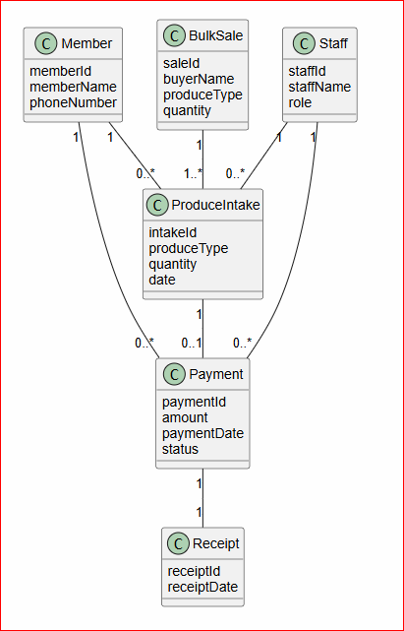

Part C — State diagram (20 min)
Pick ONE thing in your system that has a genuine lifecycle — a payment, an intake record, an application. Show its states, the triggers between them, and at least one guard.
# | Check before you move on | Done
1 | Every state is a CONDITION, not an action | Yes: The states are Recorded, Calculated, Pending Approval, Approved and Paid.
2 | Every transition names its trigger | Yes: Each transition has a trigger such as record, calculate, submit, approve, and process.
3 | At least one guard [in brackets] encodes a business rule | Yes: [amount is incorrect] sends the payment back for correction.
4 | There is a start state and at least one end state | Yes: The diagram starts at [*] and ends after the payment is Paid.
PlantUML starter
@startuml

[*] --> Recorded : record payment

Recorded --> Calculated : calculate amount

Calculated --> PendingApproval : submit payment

PendingApproval --> Approved : approve payment
PendingApproval --> Calculated : [amount is incorrect]

Approved --> Paid : process payment

Paid --> [*]

@enduml
PlantUML Diagram
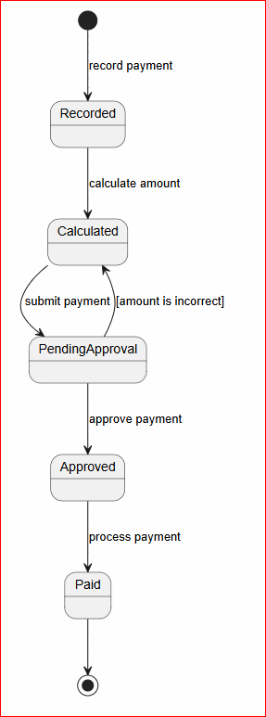

Part D — Activity diagram with swimlanes (20 min)
Model one workflow that crosses a boundary in your Week 5 deployment diagram. It must include a branch for what happens when the network or power is unavailable.
# | Check before you move on | Done
1 | Swimlanes match the devices/roles in my deployment diagram | Yes: The swimlanes are Depot Clerk, Management System and Town Office.
2 | There is a decision node for the offline case | Yes: The system checks whether the network is available.
3 | The workflow shows what staff can still do while the link is down | Yes: Staff can continue recording produce and the system stores the records in an offline queue.
4 | Duplicate-safe handling appears where data is imported | Yes: The Town Office checks for duplicate records and skips duplicates.
PlantUML starter
@startuml

|Depot Clerk|
start
:Record produce intake;

|Management System|
:Save record locally;

if (Network available?) then (Yes)

:Send record to Town Office;

|Town Office|
:Import record;
:Check for duplicate;

if (Duplicate?) then (Yes)
:Skip duplicate;
else (No)
:Save record;
endif

else (No)

|Management System|
:Store record in offline queue;
:Continue recording produce;

endif

stop

@enduml
PlantUML Diagram
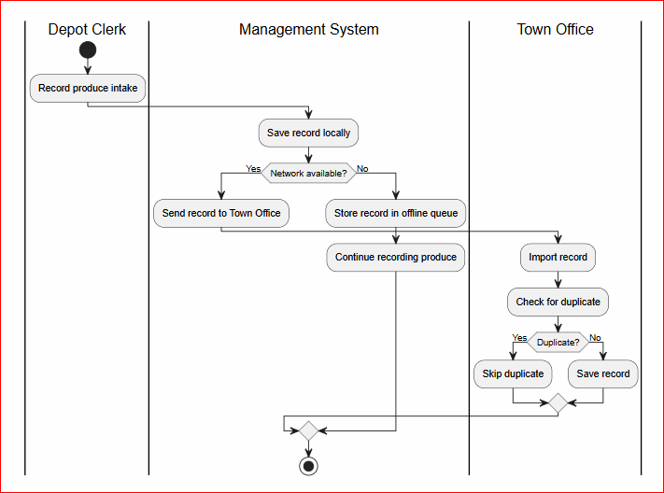

Part E — Commit (5 min)
- Save all four diagram files into week09/ in your portfolio.
git add week09/
git commit -m "Add use case, class, state and activity diagrams"
AI use: you may generate PlantUML drafts, but you must validate every diagram against your own SRS using the five checks from the lecture. Generated models routinely omit the offline branch and the approval chain — the two things that matter most here. Declare AI use in your README.

